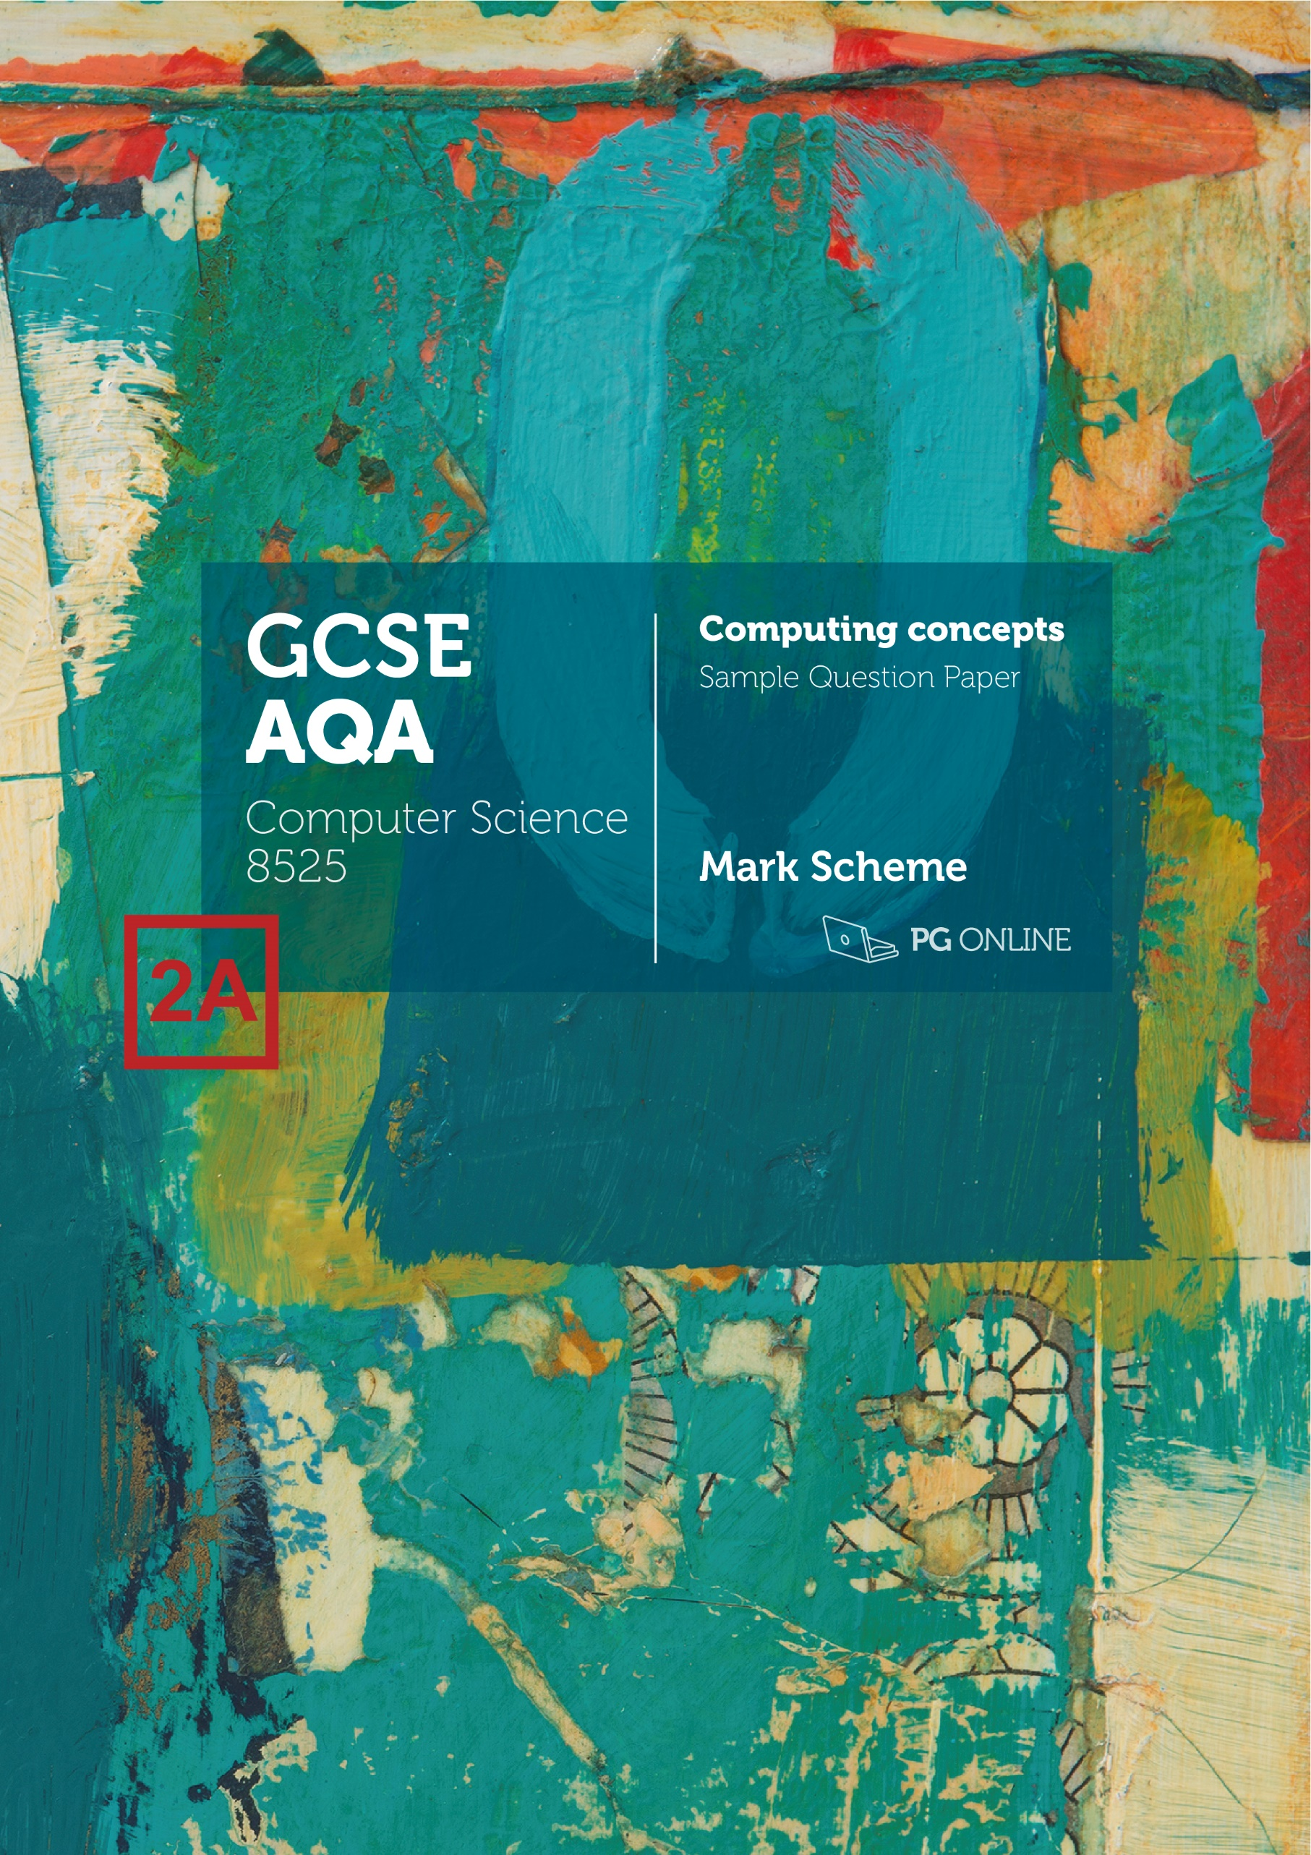

Copyright

© 2021 PG Online Limited

The contents of this unit are protected by copyright.

This Sample Paper, Sample Paper Mark Scheme and other associated files distributed with it are supplied to you by PG Online Limited under licence and may be used and copied by you only in accordance with the terms of the licence agreement between you and PG Online Limited. Except as expressly permitted by the licence, no part of the materials distributed with this unit may be used, reproduced, stored in a retrieval system, or transmitted, in any form or by any means, electronic or otherwise, without the prior written permission of PG Online Limited.

Licence agreement

This is a legal agreement between you, the teaching institution, and PG Online Limited. PG Online Limited grants to you a non-exclusive, non-transferable, revocable licence to use this Sample Paper, Sample Paper Mark Scheme and other associated files distributed with it in the course of teaching by your teachers and/or employees.

The materials distributed with this unit may be copied and used by your teachers and/or employees on a single site only in the course of their teaching. You warrant that you shall not, and shall procure that each of your teachers and/or employees shall not, share in any way any of the materials or part of the materials with any third party, including users on another site or individuals who are teachers and/or employees of a separate institution. You acknowledge and agree that the materials must remain with you, the teaching institution, and no part of the materials may be transferred to another institution. You also warrant that you shall not, and shall procure that each of your teachers and/or employees shall not, procure, authorise, encourage, facilitate or enable any third party to reproduce these materials in whole or in part without the prior permission of PG Online Limited.

In consideration of the licence granted to you, you shall indemnify PG Online Limited against all liabilities, costs, expenses, damages and losses (including but not limited to any direct, indirect or consequential losses, loss of profit, loss of reputation and all interest, penalties and legal costs and all other professional costs and expenses) suffered or incurred by PG Online Limited arising out of or in connection with the exercise by you of your rights granted under this licence.

Please write clearly, in BLOCK CAPITALS and black ink

Centre number Candidate number

Forename(s)

Surname

Date of Exam Time allowed: 1 hour 45 minutes

GCSE Computer Science

Paper 2: Computing concepts

Total Marks

PAPER 2A

Instructions

* Write in black ink or black ball-point pen. Use pencil only for drawing.
* Write your answer to each question in the space provided
* Answer all questions
* Do all rough work in this book
* Cross through any work you do not want marked
* **You are not allowed to use a calculator**

Information

* The total mark for this paper is **90**
* The student version of this paper has **18** pages

**Advice**

* For multiple-choice questions, completely fill in the lozenge next to the answer you want to select.



* Icon

  Description automatically generatedTo change your answer, cross out your original answer like this: Icon

  Description automatically generated
* If you want to go back to an answer you previously crossed out, circle the answer you now want to select like this:

**Answer ALL questions.**

|  |  |  |  |
| --- | --- | --- | --- |
| **0** | **1** | **.** | **1** |

Convert the decimal number 139 into binary.

[1 mark]

128 64 32 16 8 4 2 1  
 1 0 0 0 1 0 1 1

10001011

|  |  |  |  |
| --- | --- | --- | --- |
| **0** | **1** | **.** | **2** |

Convert the decimal number 139 into hexadecimal.

[2 marks]

8 11  
8 B  
  
8B. (2)  
  
1 mark for each hexadecimal digit in the correct order.

|  |  |  |  |
| --- | --- | --- | --- |
| **0** | **1** | **.** | **3** |

Explain why hexadecimal is often used in Computer Science.

[2 marks]

1 digit of hexadecimal represents 4 digits of binary. (1)  
As the representation is shorter, it is easier for humans to read/remember/understand. (1)

|  |  |  |  |
| --- | --- | --- | --- |
| **0** | **1** | **.** | **4** |

Shade **one** lozenge to indicate which unit prefix is the largest.

[1 mark]

|  |  |  |
| --- | --- | --- |
| **A** | giga |  |
| **B** | kilo |  |
| **C** | mega |  |
| **D** | tera |  |

|  |  |  |  |
| --- | --- | --- | --- |
| **0** | **1** | **.** | **5** |

Calculate the result of adding the following three binary numbers together.

0 1 1 0 0 0 1 0 +  
0 0 0 1 1 0 0 1 +  
0 1 0 1 0 0 1 0 _

[2 marks]

1 1 0 0 1 1 0 1 _  
1 mark for each correct nibble.

|  |  |  |  |
| --- | --- | --- | --- |
| **0** | **1** | **.** | **6** |

Explain the effect of applying a right shift to a binary number.

[2 marks]

All the bits in the number shift to the right (1)  
resulting in the number being halved. (1)

|  |  |  |  |
| --- | --- | --- | --- |
| **0** | **1** | **.** | **7** |

The ASCII code for ‘A’ is represented by the number 65.

Shade **one** lozenge to indicate the number that represents ‘A’ in Unicode.

[1 mark]

|  |  |  |
| --- | --- | --- |
| **A** | 1 |  |
| **B** | 26 |  |
| **C** | 65 |  |
| **D** | 91 |  |

(Note: candidates should know that Unicode uses the same codes as ASCII up to 127.)

|  |  |  |  |
| --- | --- | --- | --- |
| **0** | **2** |  |  |

A digital camera takes images with a colour depth of 24 bits per pixel. Both the width and height of the image is 1000 pixels.

|  |  |  |  |
| --- | --- | --- | --- |
| **0** | **2** | **.** | **1** |

Calculate, in megabytes, the file size of one image taken by the digital camera. Show your working.

[3 marks]

Size (bits) = width x height x colour depth

Size (bits) = 1000 x 1000 x 24 = 24 000 000 (1)

Size (bytes) = 24 000 000 ÷ 8 = 3 000 000 (1)

Size (megabytes) = 3 000 000 ÷ 1 000 000 = **3 MB** (1)

Alternatively:

24 bits / 8 = 3 bytes (1)

Size (bits) = width x height x colour depth

Size (bytes) = 1000 x 1000 x 3 = 3 000 000 (1)

Size (megabytes) = 3 000 000 ÷ 1 000 000 = **3 MB** (1)

1 mark for converting bits to bytes by dividing by 8.

1 mark for multiplying 1000 x 1000 to get pixels.

1 mark for dividing by 1000000 to get megabytes.

|  |  |  |  |
| --- | --- | --- | --- |
| **0** | **2** | **.** | **2** |

The company that makes the digital camera has released a new camera. It allows photos to be taken with a higher colour depth.

State the effect on file size of upgrading to the camera with a higher colour depth.

[1 mark]

The file size will increase. (1)

|  |  |  |  |
| --- | --- | --- | --- |
| **0** | **2** | **.** | **3** |

The following table shows the layout of pixels in a black and white image.

|  |  |  |  |  |
| --- | --- | --- | --- | --- |
|  |  |  |  |  |
|  |  |  |  |  |
|  |  |  |  |  |
|  |  |  |  |  |
|  |  |  |  |  |

Give the binary representation of this image.

[2 marks]

11111  
10111  
10111  
10111  
11000

The binary representation can all be on one line.

1 mark correct binary representation.  
1 mark for 1 being white and 0 being black.

Accept 0 representing black and 1 representing white.

|  |  |  |  |
| --- | --- | --- | --- |
| **0** | **2** | **.** | **4** |

The new camera has the ability to compress the photos that it takes.

Explain why it is desirable for the digital camera to be able to compress the data for the photos they take.

[2 marks]

Images that are compressed will have a smaller file size (1)  
which means they need less storage space to store them / more photos can be stored on the storage media (1).

|  |  |  |  |
| --- | --- | --- | --- |
| **0** | **2** | **.** | **5** |

The camera stores the following data:

0001111110011111001

State the result of compressing the data using run length encoding (RLE).

[2 marks]

3 0 6 1 2 0 5 1 2 0 1 1

1 mark for the first two value pairs (3 0 6 1)  
1 mark for the remainder of the compressed data.

|  |  |  |  |
| --- | --- | --- | --- |
| **0** | **3** | **.** | **1** |

Define the terms hardware and software.

[2 marks]

Hardware: The physical components of a computer system. (1)

Software: The programs (and operating system) used by a computer. (1)

|  |  |  |  |
| --- | --- | --- | --- |
| **0** | **3** | **.** | **2** |

Give the name of the logic gate shown in **Figure 1**.

[1 mark]

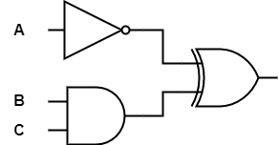

**Figure 1**

NOT gate

Look at the following logic circuit in **Figure 2**.



**P**

**Figure 2**

|  |  |  |  |
| --- | --- | --- | --- |
| **0** | **3** | **.** | **3** |

Complete the truth table for the logic circuit in **Figure 2**. Spare columns have been provided for your working.

[3 marks]

(1)

(1)

(1)

|  |  |  |  |  |  |
| --- | --- | --- | --- | --- | --- |
| A | B | C | Not A | B AND C | P |
| 0 | 0 | 0 | 1 | 0 | 1 |
| 0 | 0 | 1 | 1 | 0 | 1 |
| 0 | 1 | 0 | 1 | 0 | 1 |
| 0 | 1 | 1 | 1 | 1 | 0 |
| 1 | 0 | 0 | 0 | 0 | 0 |
| 1 | 0 | 1 | 0 | 0 | 0 |
| 1 | 1 | 0 | 0 | 0 | 0 |
| 1 | 1 | 1 | 0 | 1 | 1 |

Marks as indicated for the P column only.

|  |  |  |  |
| --- | --- | --- | --- |
| **0** | **3** | **.** | **4** |



Give an expression for the circuit in **Figure 2**.

[3 marks]

**P =** (NOT A) XOR (B AND C)

Alternatively:

1 mark for (NOT A)  
1 mark for (B AND C)  
1 mark for correct position of XOR

|  |  |  |  |
| --- | --- | --- | --- |
| **0** | **4** | **.** | **1** |

Describe the **three** stages of the fetch-execute cycle.

[4 marks]

In the fetch stage, the next instruction is fetched from main memory (to the CPU). (1)

In the decode (1) stage, the instruction is decoded to work out what it is. (1)

In the execute stage, the instruction is executed / carried out (by the control unit). (1)

A CPU has a clock speed of 2 GHz and two processor cores.

|  |  |  |  |
| --- | --- | --- | --- |
| **0** | **4** | **.** | **2** |

State the effect of replacing the processor to one that still has two processor cores but has a clock speed of 4 GHz.

[1 mark]

The processor will be able to process twice as many instructions per second. (1)

|  |  |  |  |
| --- | --- | --- | --- |
| **0** | **4** | **.** | **3** |

A different computer has a processor with the same clock speed and four processor cores. However, when a user runs a particular program, they find that it runs no faster.

Explain how this is possible.

[2 marks]

If the program is only capable of using one core (1) then the additional cores will not be used (1) (so no gain in speed will be achieved).

|  |  |  |  |
| --- | --- | --- | --- |
| **0** | **4** | **.** | **4** |

Shade **one** lozenge to indicate the purpose of the arithmetic logic unit on a CPU.

[1 mark]

|  |  |  |
| --- | --- | --- |
| **A** | directs the operation of the processor |  |
| **B** | fetch data from RAM |  |
| **C** | perform calculations such as addition and multiplication |  |
| **D** | store data in RAM |  |

|  |  |  |  |
| --- | --- | --- | --- |
| **0** | **4** | **.** | **5** |

Shade **one** lozenge to indicate the component that is the fastest to read or write data to.

[1 mark]

|  |  |  |
| --- | --- | --- |
| **A** | Cache |  |
| **B** | Solid state hard drive |  |
| **C** | RAM |  |
| **D** | Register |  |

|  |  |  |  |
| --- | --- | --- | --- |
| **0** | **4** | **.** | **6** |

ROM is non-volatile. Explain the term non-volatile.

[2 marks]

Non-volatile means that the data stored will not be lost (1) if the power is turned off (1).

|  |  |  |  |
| --- | --- | --- | --- |
| **0** | **4** | **.** | **7** |

A computer makes use of a magnetic hard disk for secondary storage.

Describe how data is stored and retrieved from a magnetic hard disk.

[3 marks]

One or more disks rotate on a spindle (1)  
the disks are known as platters (1)  
A drive head moves to the correct track which contains the data (1).  
Once the drive has spun to the correct sector… (1)  
… the drive head reads or writes the data (1)  
by changing the magnetic field to north or south (1).

|  |  |  |  |
| --- | --- | --- | --- |
| **0** | **4** | **.** | **8** |

Explain **one** advantage of cloud storage when compared to local storage.

[2 marks]

Data is stored on servers on the Internet (1) which allows it to be accessed anywhere in the world / with Internet access (1).

Storage space is rented (1) which makes the initial costs of storage easier for small companies/people to afford / which is more convenient than buying additional secondary storage (1).

Backups of storage are automatically made by the company providing the storage (1) which saves the user having to remember to backup.

Or any other appropriate advantage with an explanation.

|  |  |  |  |
| --- | --- | --- | --- |
| **0** | **5** | **.** | **1** |

The table below shows two different types of software.

Complete the table to give **two** examples of each type of software.

[4 marks]

|  |  |
| --- | --- |
| **Application software** | **System software** |
|  |  |
|  |  |

1 mark for each example.

Application software examples

Word processor  
Spreadsheet  
Presentation software  
Web browser  
Computer game  
Calculator  
PDF viewer  
Accept any other examples of application software.

System software

Operating system  
utility programs  
kernel  
device drivers  
defragmentation software  
disk compression software  
formatting utility

or any other system software or examples of utility programs.

|  |  |  |  |
| --- | --- | --- | --- |
| **0** | **5** | **.** | **2** |

An operating system is responsible for managing the applications and security of a system.

State **two** other parts of a computer system that an operating system handles.

[2 marks]

Processor(s) (1)  
Memory / RAM (1)  
Input devices (1)  
Output devices (1)

Accept I/O devices for 1 mark.

|  |  |  |  |
| --- | --- | --- | --- |
| **0** | **6** | **.** | **1** |

The program in **Figure 3** shows computer code.

**Figure 3**

MOV R0, #7  
MOV R1, #8  
ADD R2, R0, R1  
MOV #9, R2

Shade **one** lozenge to indicate the type of language that has been used.

[1 mark]

|  |  |  |
| --- | --- | --- |
| **A** | A high-level language |  |
| **B** | Assembly language |  |
| **C** | Machine code |  |
| **D** | Structured Query Language (SQL) |  |

|  |  |  |  |
| --- | --- | --- | --- |
| **0** | **6** | **.** | **2** |

Some languages, such as Python, need to be interpreted.

Shade **one** lozenge to indicate an advantage of using an interpreted language.

[1 mark]

|  |  |  |
| --- | --- | --- |
| **A** | It is easier to learn an interpreted language |  |
| **B** | The programming code can be run on any computer architecture that has an interpreter available |  |
| **C** | The program will run faster |  |
| **D** | It is harder to learn an interpreted language |  |

|  |  |  |  |
| --- | --- | --- | --- |
| **0** | **7** | **.** | **1** |

A driver of a car connects their smartphone to the in-car entertainment system using Bluetooth.

State the type of network they have created.

[1 mark]

Personal Area Network / PAN (1)

A school wishes to create a classroom with PCs that are all connected to a wired network in a star topology.

|  |  |  |  |
| --- | --- | --- | --- |
| **0** | **7** | **.** | **2** |

Draw the network topology below. Include any other hardware required to make the network in the diagram.

[3 marks]

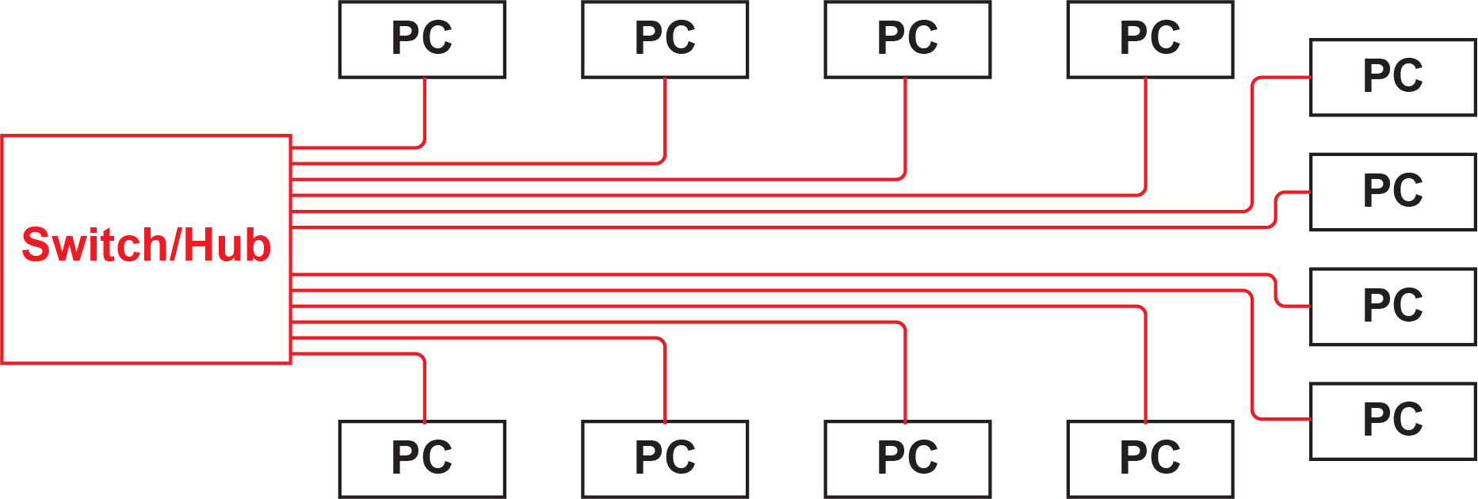

A line/cable from each PC to the switch/hub. (1)  
A central node / square. (1)  
Central node labelled as a switch or hub. (1)  
Accept the cables going in any logical location – for example, the cable may go around three walls of the room to reach the PC on the bottom left.

|  |  |  |  |
| --- | --- | --- | --- |
| **0** | **7** | **.** | **3** |

Give **one** advantage to using a bus topology when setting up a classroom’s network.

[1 mark]

Fewer cables would have been required. (1)  
It would be easier to install (due to fewer cables). (1)  
No need to purchase a switch/hub. (1)  
Easier to add another PC if the ports on the switch are all taken up. (1)

|  |  |  |  |
| --- | --- | --- | --- |
| **0** | **7** | **.** | **4** |

Wireless networks are now commonly used in schools, businesses, cafes, and homes.

Discuss the advantages and disadvantages of wireless networks as opposed to wired networks.

In your answer you should include an explanation of the reasons wireless networks are now commonly used and consider any legal, ethical and environmental issues related to the use of wireless networks.

[9 marks]

|  |  |  |
| --- | --- | --- |
| **Level** | **Description** | **Mark range** |
| 3 | Answer demonstrates a **sustained line** of reasoning with a **substantiated** explanation for the common use of wireless networks that includes both technological and social reasons.  There is a **logically structured** consideration of the advantages and the disadvantages associated with the common use of wireless networks – including relevant points covering **at least two** of legal, ethical and environmental issues. | 7-9 |
| 2 | Answer includes an explanation for the common use of wireless networks that includes both technological and social reasons.  There is a logically structured consideration of the advantages and the disadvantages associated with the common use of wireless networks – including **one or two** relevant points related to legal, ethical and environmental issues. | 4-6 |
| 1 | The answer includes either a description of some of the reasons for the common use wireless networks and/or brief consideration of the advantages and/or disadvantages associated with wireless networks. | 1-3 |
| No creditworthy answer | | 0 |

**Guidance – Indicative Response (common use of wireless networks)**

Cheap wireless access points / wireless routers / hardware now available.  
Most home broadband packages include a router with wireless capabilities.  
Cafes and many other publicly available places have free to access Wi-Fi / WLAN / wireless networks.  
Many devices, such as smartphones and tablets can only connect to a network using Wi-Fi/wireless/WLAN.  
Newer Wi-Fi standards (such as 802.1bc) .

**Guidance – Indicative Response (advantages of wireless networks)**

There is no need to use a cable to connect the network.  
Adding new devices is very easy.  
Connecting a new device just requires the network password (if the wireless connection is encrypted) rather than a physical cable.  
The user device can easily be moved whilst still connected to the network.  
The decreased need for cables means that there is less environmental damage from both the manufacture and disposal cables themselves and also any construction work to install them.

**Guidance – Indicative Response (disadvantages of wireless networks)**

These networks, in general, are not as fast as wired networks.  
Wired networks typically operate faster / have higher bandwidth in real situations (as opposed to theoretical speeds).  
Wireless networks will have a significant drop in bandwidth when there are walls or obstacles in the way or if the device is a long way from the access point.  
Wired networks (typically) make use of a switch which copes well with lots of devices connecting to the network. Wireless networks suffer badly from many devices being added to the network, with a significant fall in the speed of the network (or no network being available).  
Wireless networks are more of a cyber security risk as the user can connect to them from outside the building / some distance.  
Many wireless networks have no security/encryption, whilst others may use Wireless Encryption Protocol (WEP) which is very easy to crack.  
Most wireless networks require a pre-shared key (PSK) in order to use them. If users are not made aware of this key, it may be far harder to connect to the network than a wired one.  
Wireless networks are susceptible to a man-in-the-middle attack, where the device connects to a wireless access point that is controlled by the hacker/eavesdropper.  
As wireless networks suffer from security risks, they must be carefully considered as any business/organisation needs to make sure that personal data is held and processed securely under the data protection act.  
Wireless network devices and access points are frequently being updated to new standards, meaning that equipment is often being manufactured/disposed of with associated environmental damage.  
As wireless networks are easier to use, they have led to more increased use in public areas and on mobile devices. This has led to a decrease in privacy.

|  |  |  |  |
| --- | --- | --- | --- |
| **0** | **8** | **.** | **1** |

One method of network security is a firewall.

State **two** other methods of network security.

[2 marks]

Authentication (1)  
Encryption (1)  
MAC address filtering (1)  
Accept use of HTTPS / Secure Hypertext Transfer Protocol as a specific example of encryption. (1)

|  |  |  |  |
| --- | --- | --- | --- |
| **0** | **8** | **.** | **2** |

Describe how a firewall helps to improve the security of a network.

[3 marks]

A firewall monitors incoming/outgoing network traffic / packets. (1)  
It decides whether to allow or block specific traffic / packets (1)  
…based on a defined set of security rules. (1)  
The process of checking individual packets is known as packet inspection. (1)  
Ports that are unused can be blocked (1)  
… which prevents attacks being made through this type of port (1).

|  |  |  |  |
| --- | --- | --- | --- |
| **0** | **8** | **.** | **3** |

Define the term network protocol.

[1 mark]

A set of rules for how data is transmitted between devices in a network. (1)

|  |  |  |  |
| --- | --- | --- | --- |
| **0** | **8** | **.** | **4** |

State **two** protocols that are used in the sending and receiving of email.

[2 marks]

Sending email:

SMTP / Simple Mail Transfer Protocol (1)

Receiving email:  
IMAP / Internet Message Access Protocol (1)

Accept POP / Post Office Protocol / POP3 (1)

1 mark for a sending protocol

1 mark for a receiving protocol

|  |  |  |  |
| --- | --- | --- | --- |
| **0** | **9** | **.** | **1** |

The table below shows three weak passwords.

Complete the table to give a reason why each is a poor choice of password.

[3 marks]

|  |  |
| --- | --- |
| **Password** | **Reason it is a poor choice of password** |
| admin | It is used as a default password (1) |
| 123456 | This password is easy to guess / it does not contain letters or symbols making it easy to guess / it is commonly used as a password so very easy to guess (1) |
| Performance | A computer could easily try all words in the dictionary / it is susceptible to a dictionary attack (1)  Accept: it does not contain any numbers or symbols making it easier to guess |

|  |  |  |  |
| --- | --- | --- | --- |
| **0** | **9** | **.** | **2** |

Shade **one** lozenge that shows the correct definition of white-box penetration testing.

[1 mark]

|  |  |  |
| --- | --- | --- |
| **A** | Makes use of a common set of malware to penetrate  the system |  |
| **B** | Simulates an external hacking or cyber warfare attack |  |
| **C** | The penetration tester has knowledge of and basic credentials for the target system they are testing |  |
| **D** | The penetration tester has **no** knowledge or credentials for the target system they are testing |  |

|  |  |  |  |
| --- | --- | --- | --- |
| **0** | **9** | **.** | **3** |

Shade **one** lozenge that shows a cyber security threat that is **not** a type of malware.

[1 mark]

|  |  |  |
| --- | --- | --- |
| **A** | Computer virus |  |
| **B** | Phishing |  |
| **C** | Spyware |  |
| **D** | Trojan |  |

|  |  |  |  |
| --- | --- | --- | --- |
| **0** | **9** | **.** | **4** |

One security measure that helps to prevent cyber security threats is the use of password systems.

State **one** other security measure that is used to detect or prevent cyber security threats.

[1 mark]

Biometric measures / fingerprint scanner / retina scanner / facial recognition (1).  
CAPTCHA (1).  
Email confirmations to confirm a user’s identity.  
Automatic software updates.

Accept other similar security measures.

|  |  |  |  |
| --- | --- | --- | --- |
| **1** | **0** |  |  |

A relational database is used in a new website for a personal trainer who takes online bookings.

Customers are able to make a booking on a certain date and time for a duration between 0.5 and 2 hours.

As the website is new, only a small number of customers and bookings have been added to the tables so far.

The contents of the tables are shown in **Figure 3**.

**Figure 3**

**Bookings**

|  |  |  |  |  |
| --- | --- | --- | --- | --- |
| **BookingID** | **CustomerID** | **Date** | **Time** | **Hours** |
| 22 | 4 | 21/06/21 | 10:00 | 0.5 |
| 23 | 1 | 21/06/21 | 11:00 | 1.0 |
| 24 | 2 | 21/06/21 | 16:00 | 1.5 |
| 25 | 4 | 22/06/21 | 14:00 | 0.5 |
| 26 | 3 | 22/06/21 | 16:00 | 2.0 |

**Customers**

|  |  |  |  |
| --- | --- | --- | --- |
| **CustomerID** | **Name** | **Age** | **PhoneNumber** |
| 1 | Patrick | 18 | 01184960243 |
| 2 | Sia | 32 | 07700900194 |
| 3 | Elisa | 25 | 01632960246 |
| 4 | Jay | 19 | 01184960855 |
| 5 | Rebecca | 28 | 07700900549 |

|  |  |  |  |
| --- | --- | --- | --- |
| **1** | **0** | **.** | **1** |

State the field in the **Customers** table that is the primary key.

[1 mark]

CustomerID

|  |  |  |  |
| --- | --- | --- | --- |
| **1** | **0** | **.** | **2** |

State the most suitable data type for the PhoneNumber field.

[1 mark]

String / varchar (1)

Accept text.

Do not accept integer as this will not store the leading zero.

|  |  |  |  |
| --- | --- | --- | --- |
| **1** | **0** | **.** | **3** |

Write an SQL query that finds the Name, Time and Hours for all customers who have a booking on 21/06/21.

[5 marks]

SELECT Name, Time, Hours  
FROM Booking, Customers   
WHERE Date = '21/06/21'  
AND Bookings.CustomerID = Customers.CustomerID

Patrick has rung to cancel all his bookings due to an injury.

A query has been created to remove all Patrick’s bookings and is shown in **Figure 4**.

**Figure 4**

DELETE FROM Bookings

WHERE CustomerID > 1

|  |  |  |  |
| --- | --- | --- | --- |
| **1** | **0** | **.** | **4** |

The query contains one error. Refine the query in **Figure 4** to correct the error.

[1 mark]

DELETE FROM Bookings

WHERE CustomerID = 1

Acknowledgements

Artwork



*Change of Heart*

© Karen Stamper (30 cm × 30 cm)

Paper collage and acrylic on board

www.karenstampercollage.com